

**UNIVERSITY OF PETROLEUM & ENERGY STUDIES**

**Dehradun**

**CONTINOUS INTEGRATION**

**AND**

**CONTINOUS DELIVERY**

**Experiment**

**Name: Rakshit Kapoor**

**Course: B. TECH CSE DevOps (2018-22)**

**Roll no.: R171218082**

**Sapid: 500067642**

**Experiment**

**Create pipeline using Jenkinsfile**

**Step-1:** Create a new Maven Project on Eclipse and push the project on GitHub.

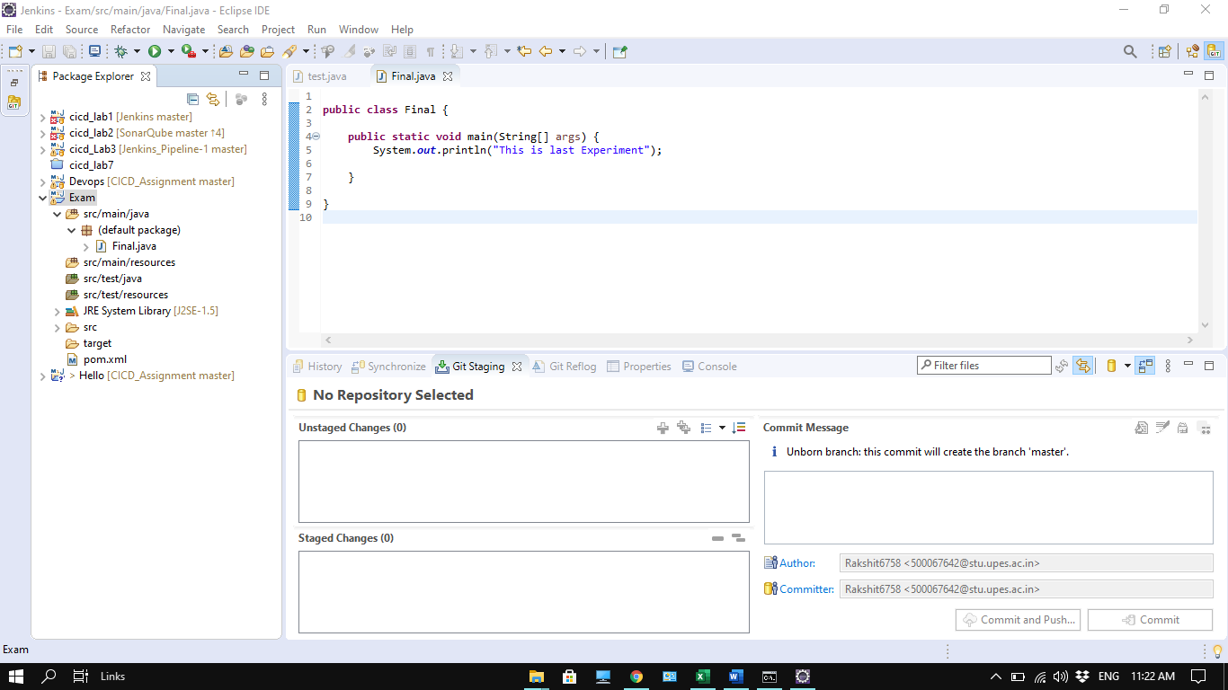

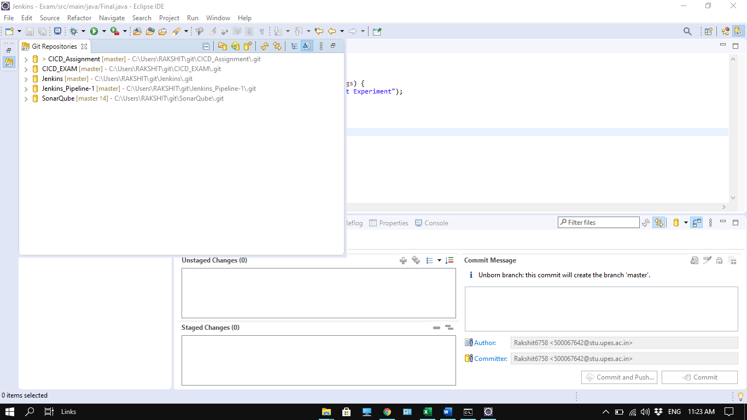

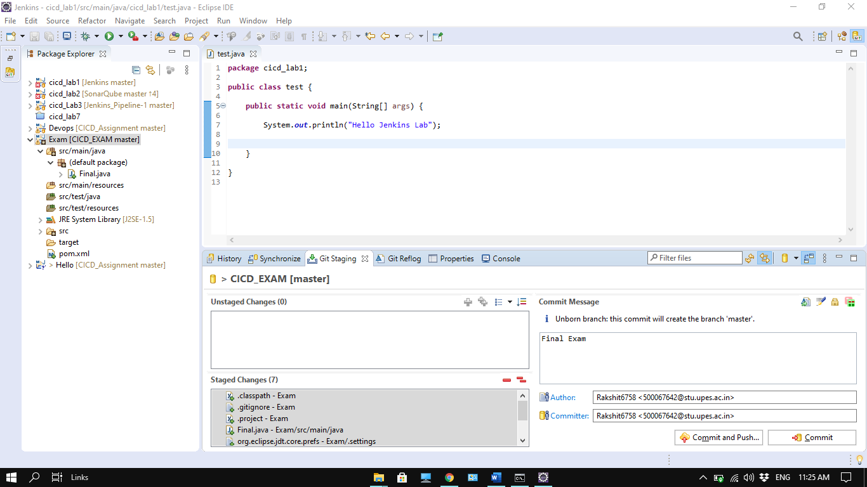

**Step-2:** Create a Jenkinsfile on GitHub.

Link: <https://github.com/Rakshit6758/CICD_EXAM/tree/master/Exam>

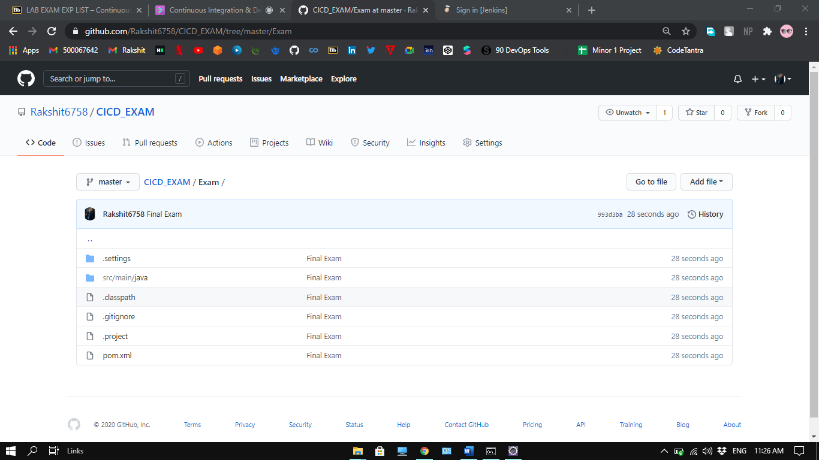

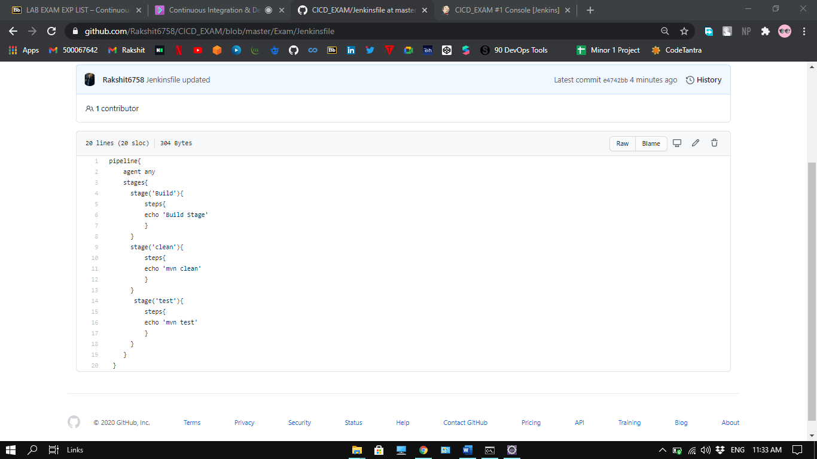

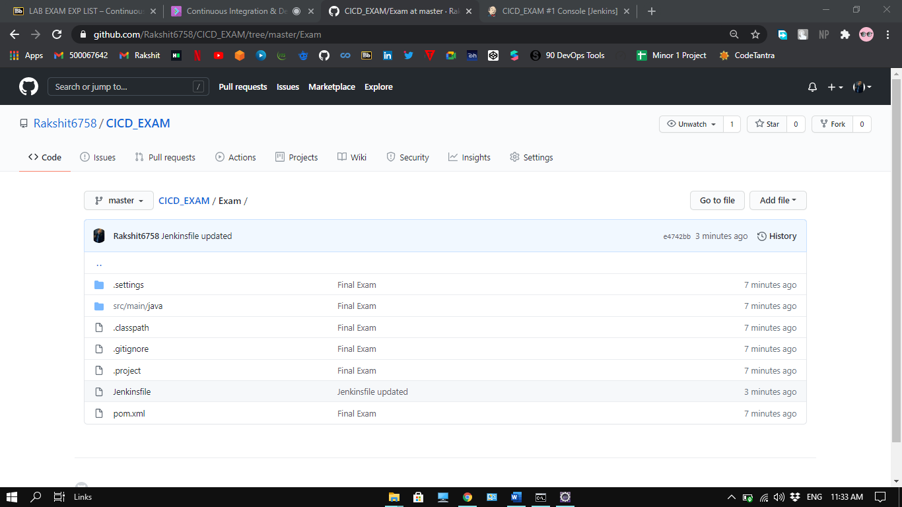

**Step-3:** Start Jenkins and dashboard will be displayed

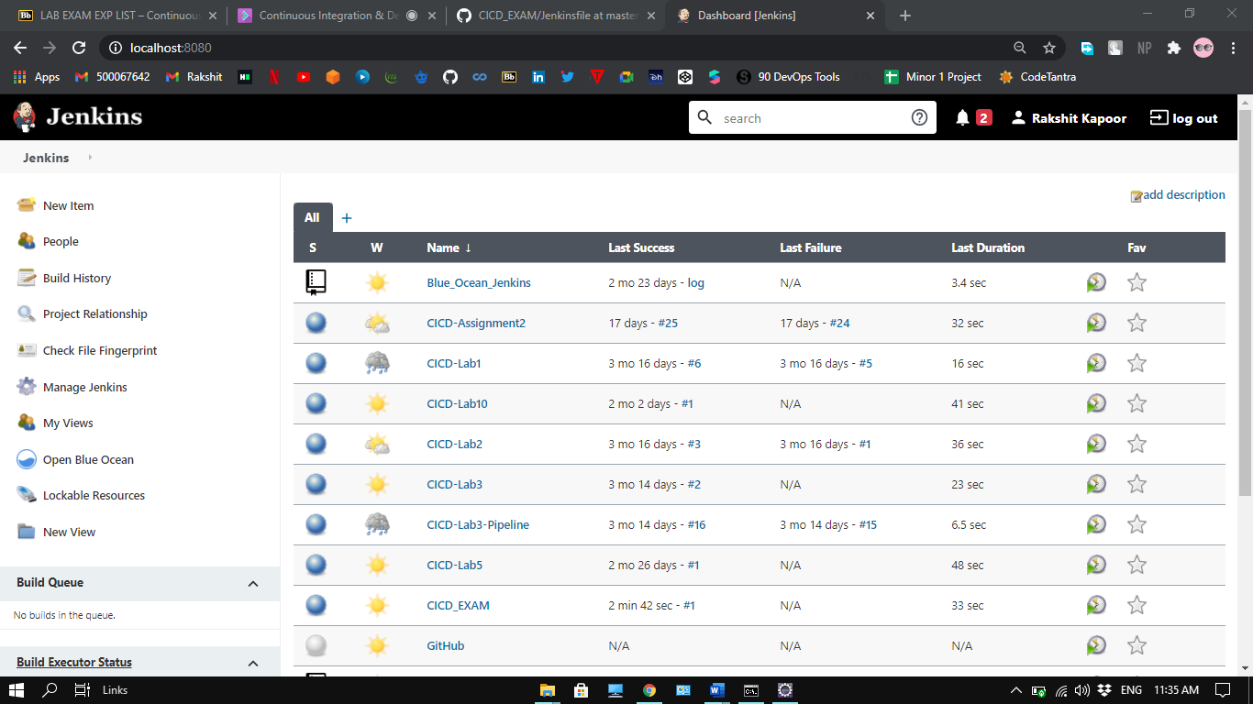

**Step-4:** Click on the new item and select pipeline project and provide the name to it and click on ok.

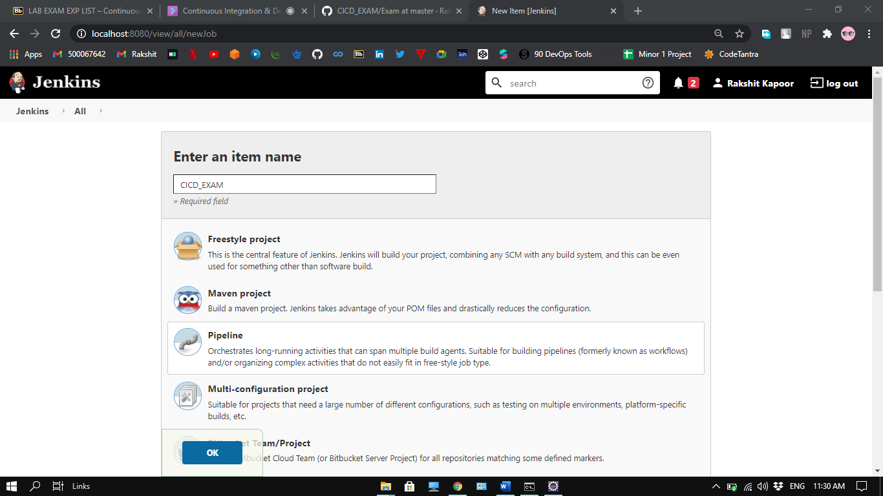

**Step-5:** provide the URL of the repository and path of Jenkinsfile. Click on Save.

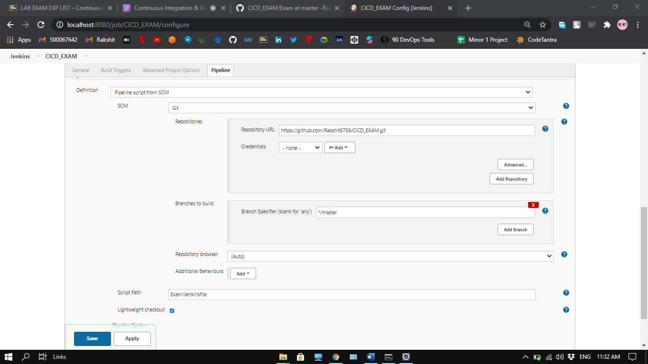

**Step-6:** Click on Build now to see the pipeline

